**Capstone-Project**

**Application:**

Clone the below mentioned repo and deploy the application. (Run the application in Port 80 HTTP)

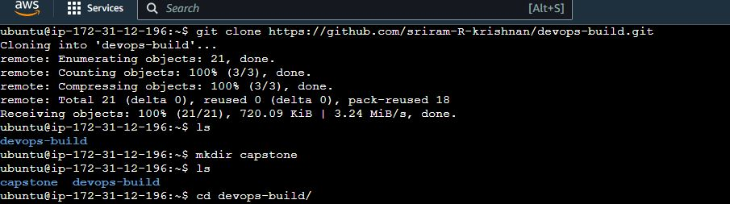

**Docker:**

Dockerise the Application by creating Docker file.

Docker File:

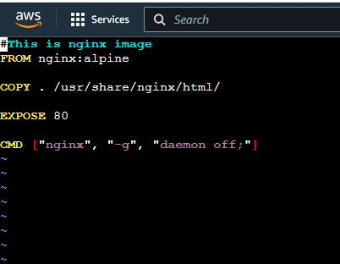

Docker compose File:

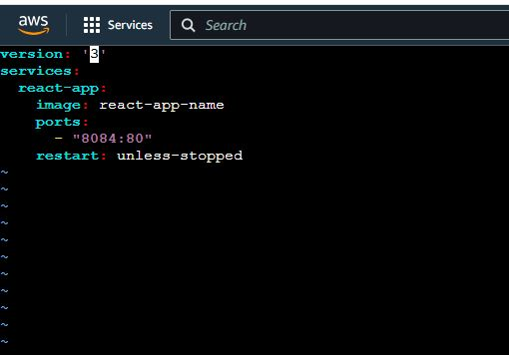

Build Docker file:

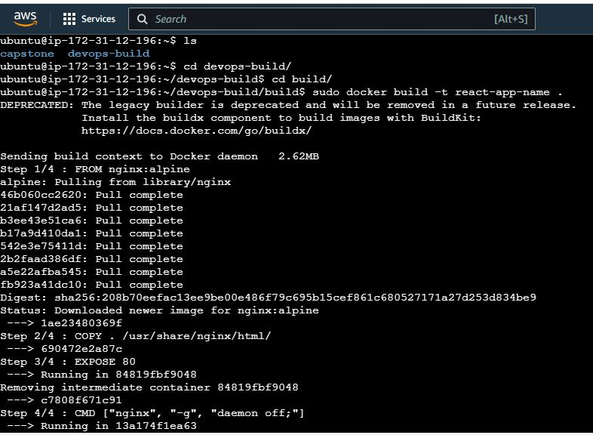

Docker images:

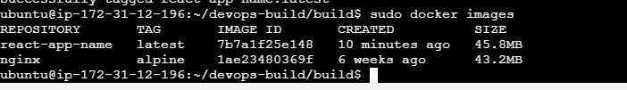

Container ID and Port configuration details:

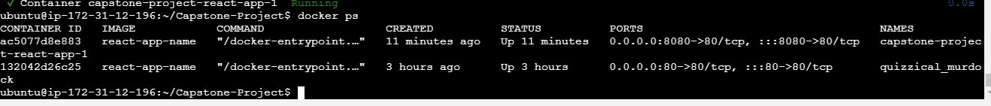

Run the Container

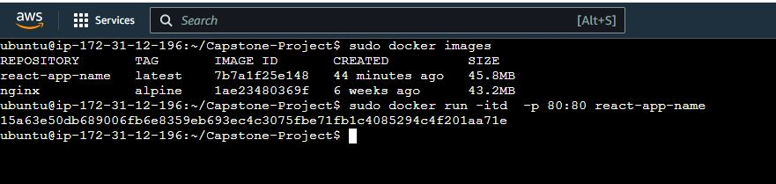

Run the site using Port 80:

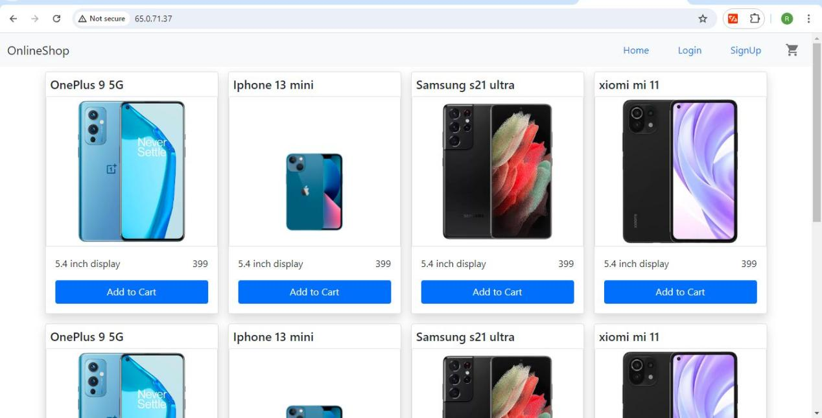

**Bash Scripting:**

Created two Bash script files build.sh and deploy.sh

Build.sh 🡪 For building docker images

Deploy.sh 🡪 For deploying the image to the server

Capstone-Project directory details:

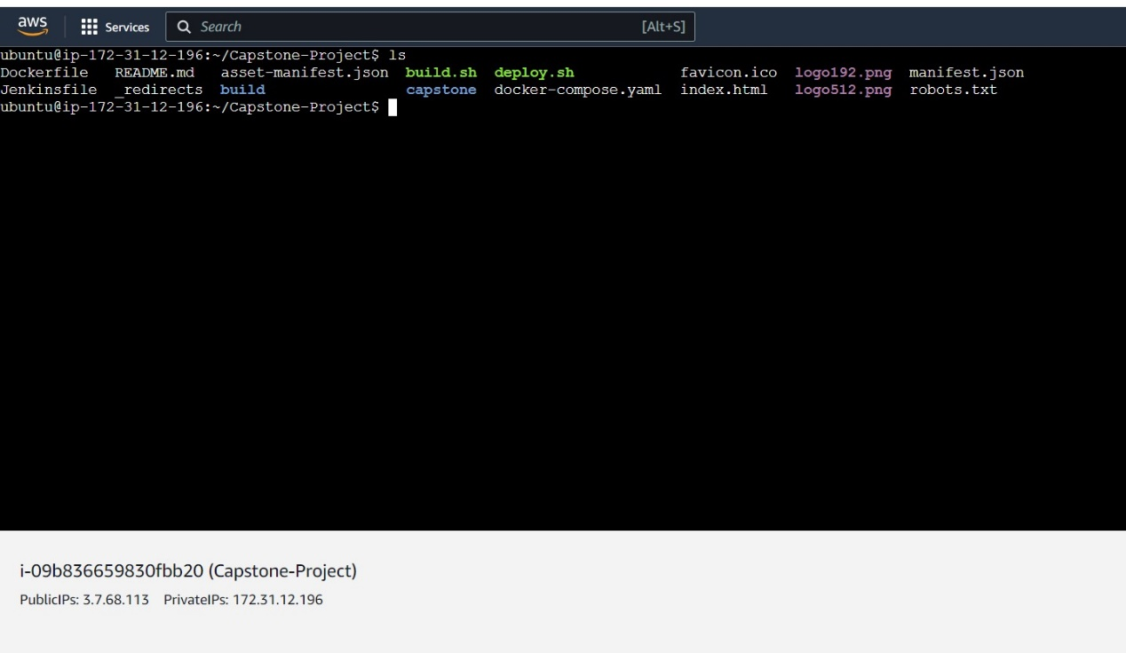

Build.sh:

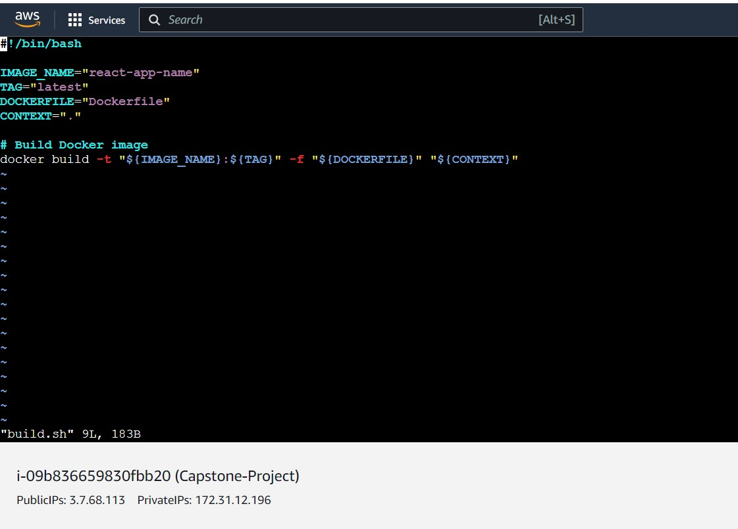

Deploy.sh:

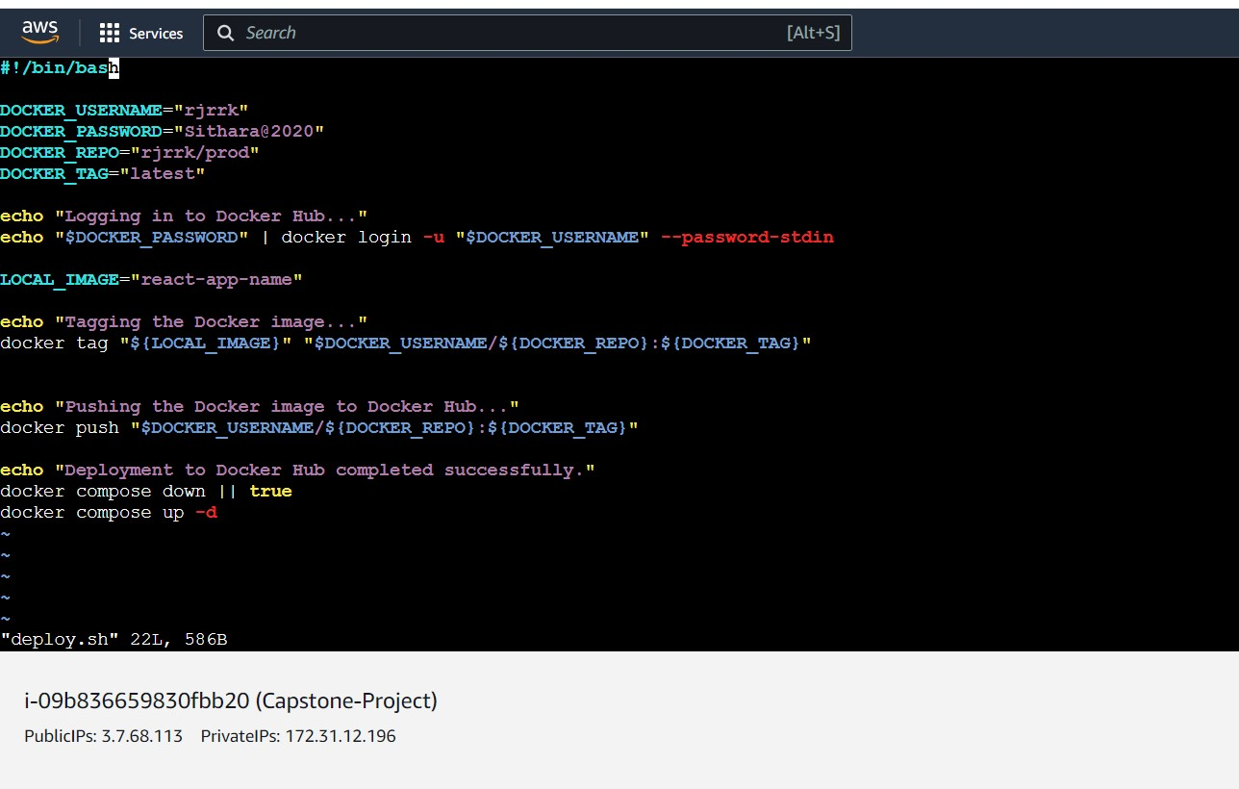

**Github URL:** [**https://github.com/rjrrk/Capstone-Project.git**](https://github.com/rjrrk/Capstone-Project.git)

Git Branch:

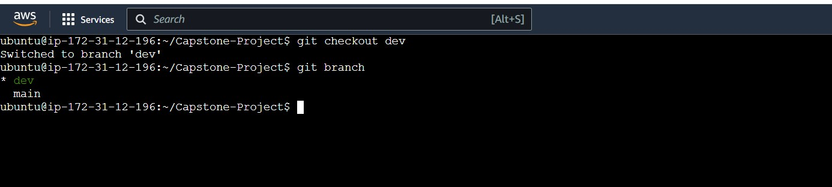

Adding the details to dev branch:

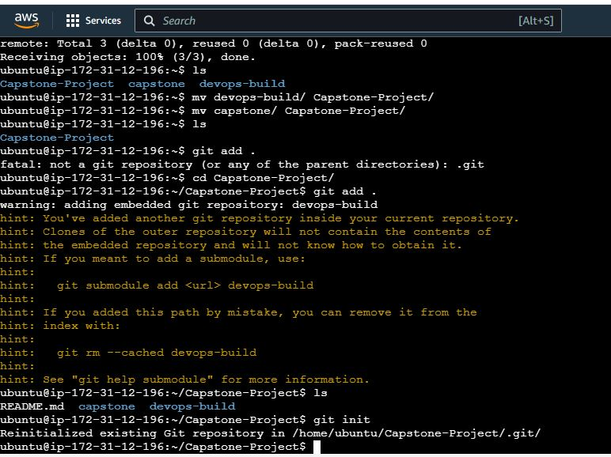

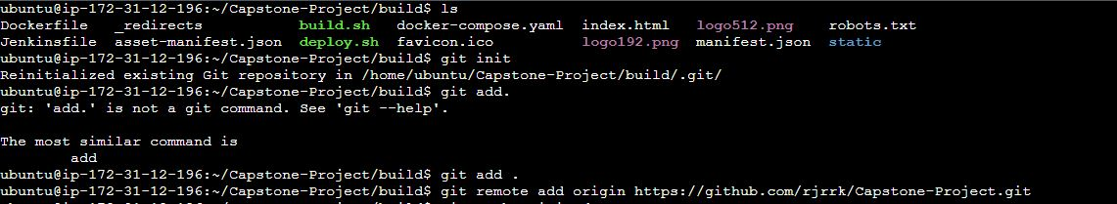

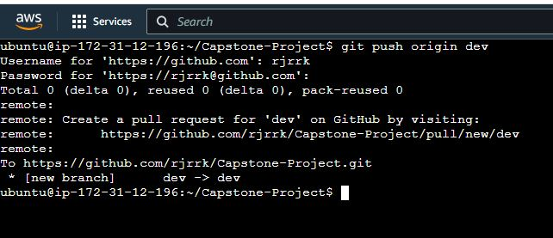

Github Page:

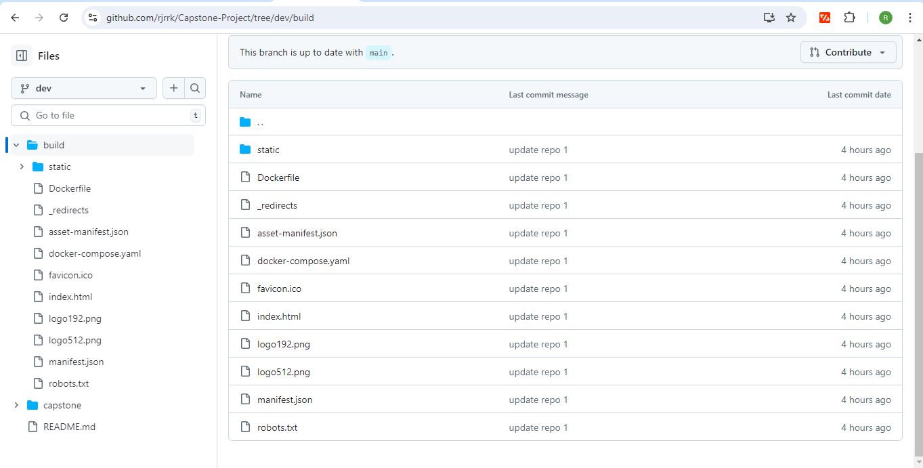

**Docker HUB:**

Created two repositories Prod and Dev:

Prod 🡪 Private repo

Dev 🡪 Public repo

Docker HUB URL: <https://hub.docker.com/repositories/rjrrk>

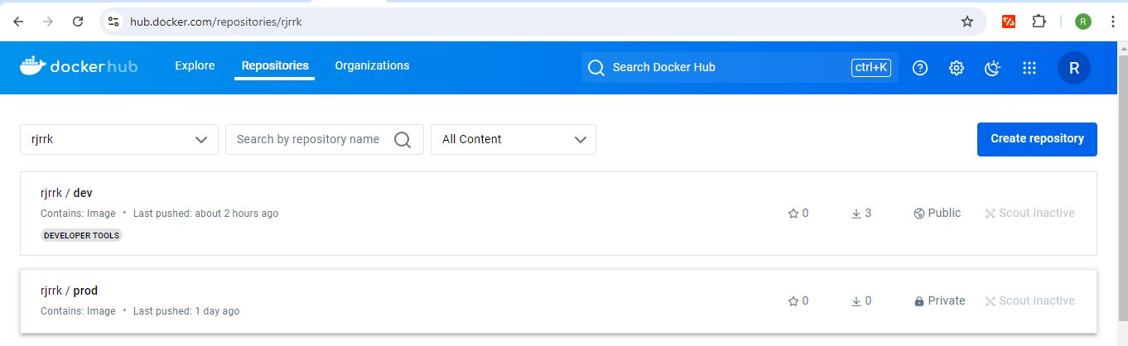

Prod repo:

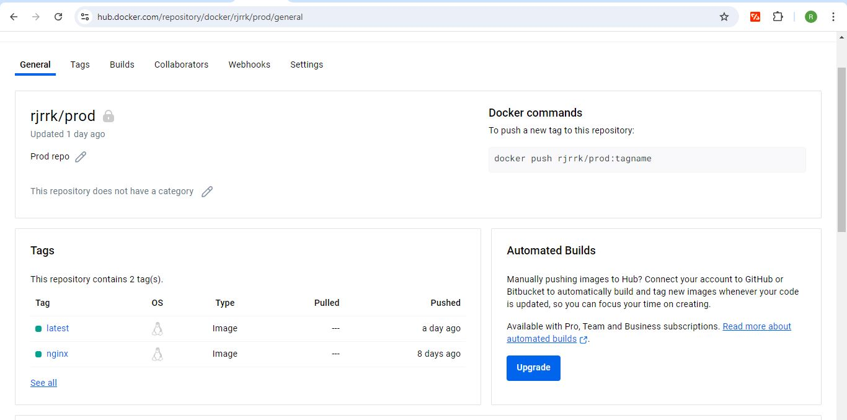

Dev repo:

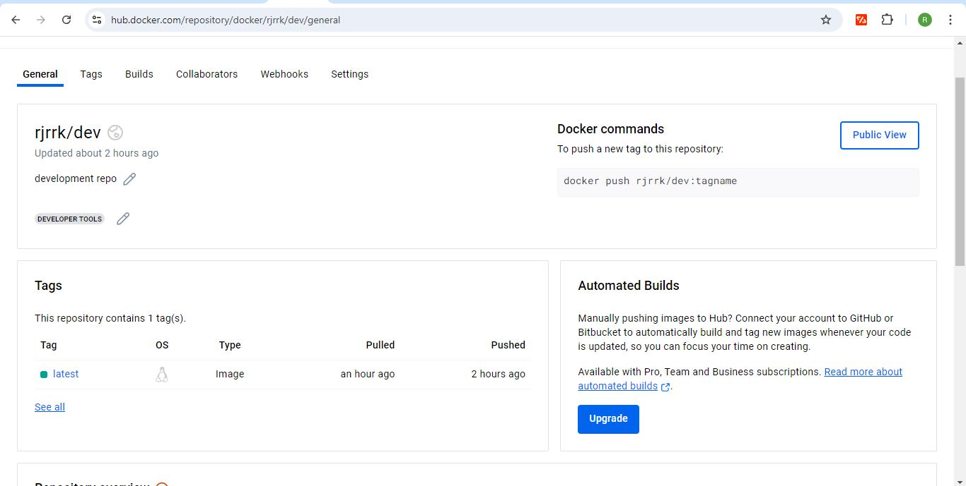

**Jenkins:**

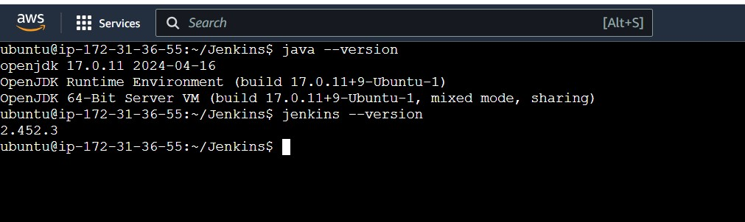

Git log 🡪 Merged dev branch with the main branch to push the image into docker hub Prod repository:

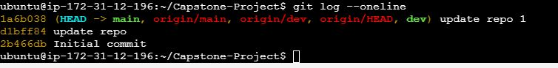

Create a Jenkins file and push the Jenkins file in the dev and main branch for the Multibranch pipeline project:

Jenkins File:

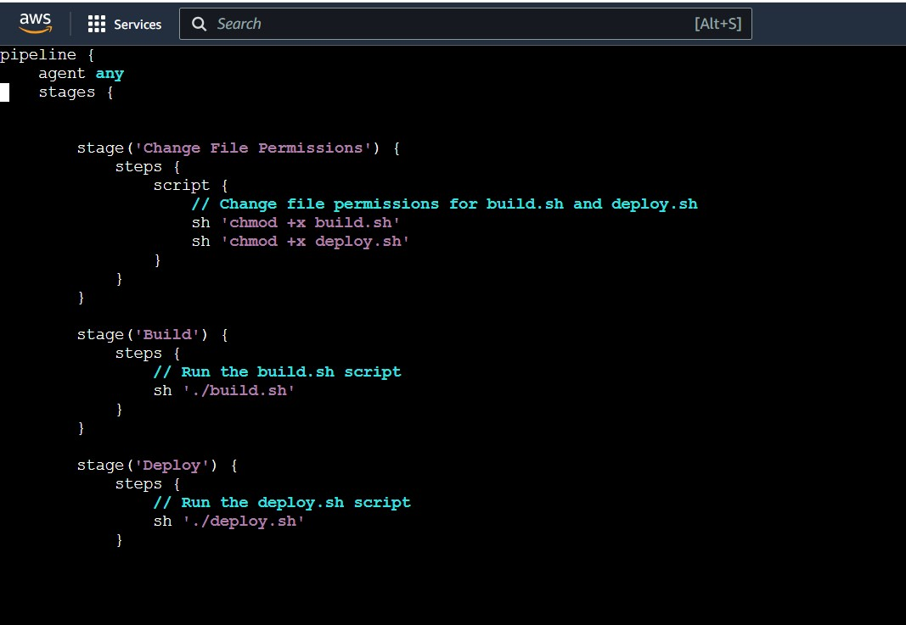

Build output:

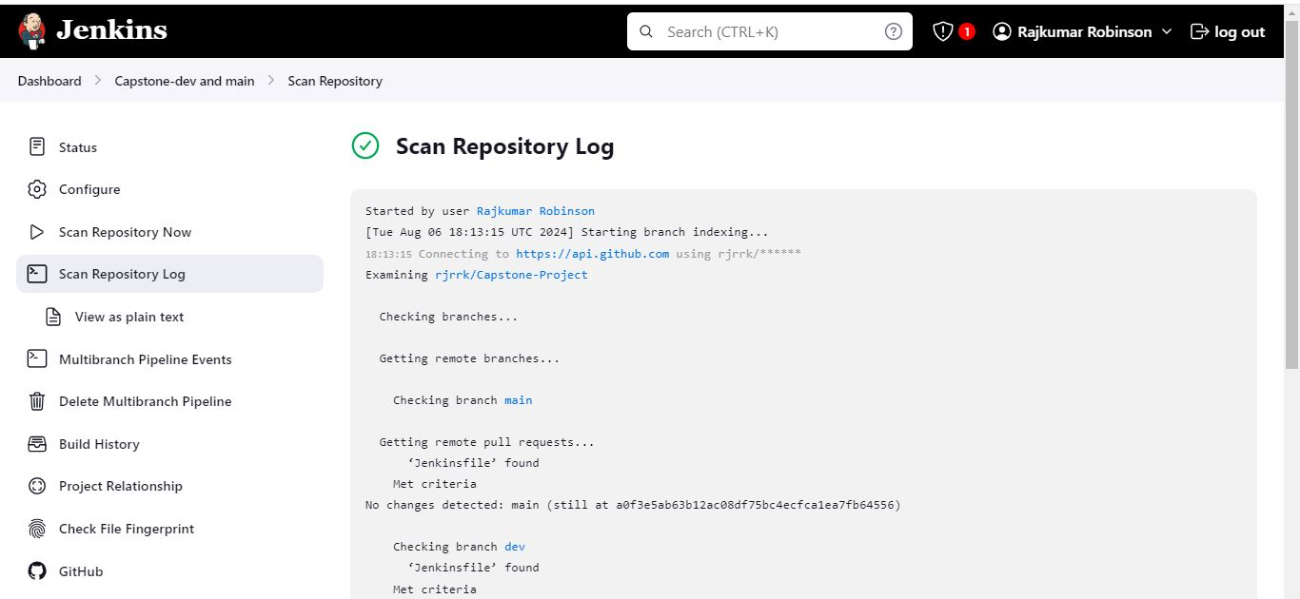

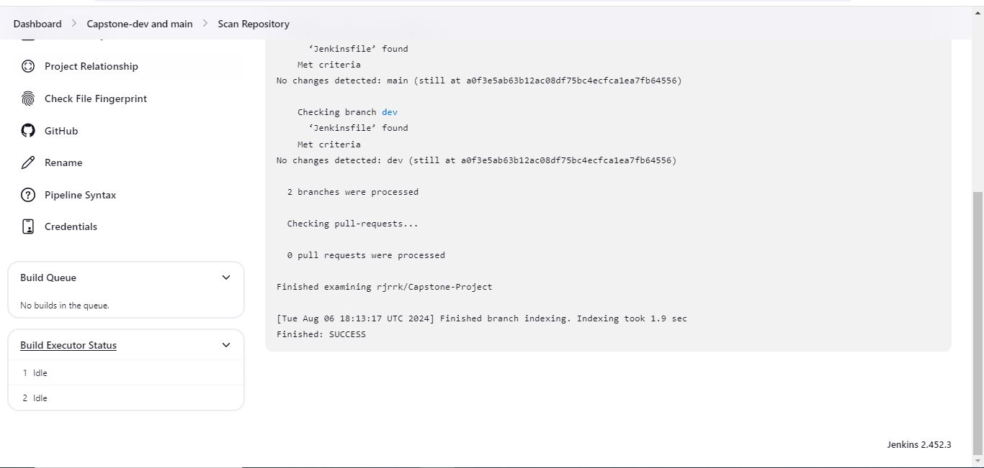

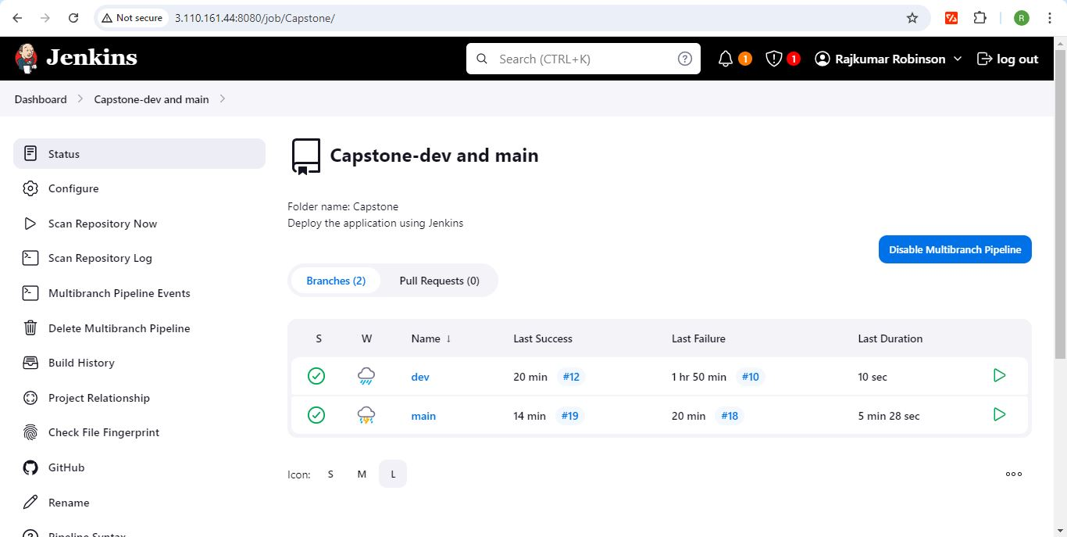

Console Output:

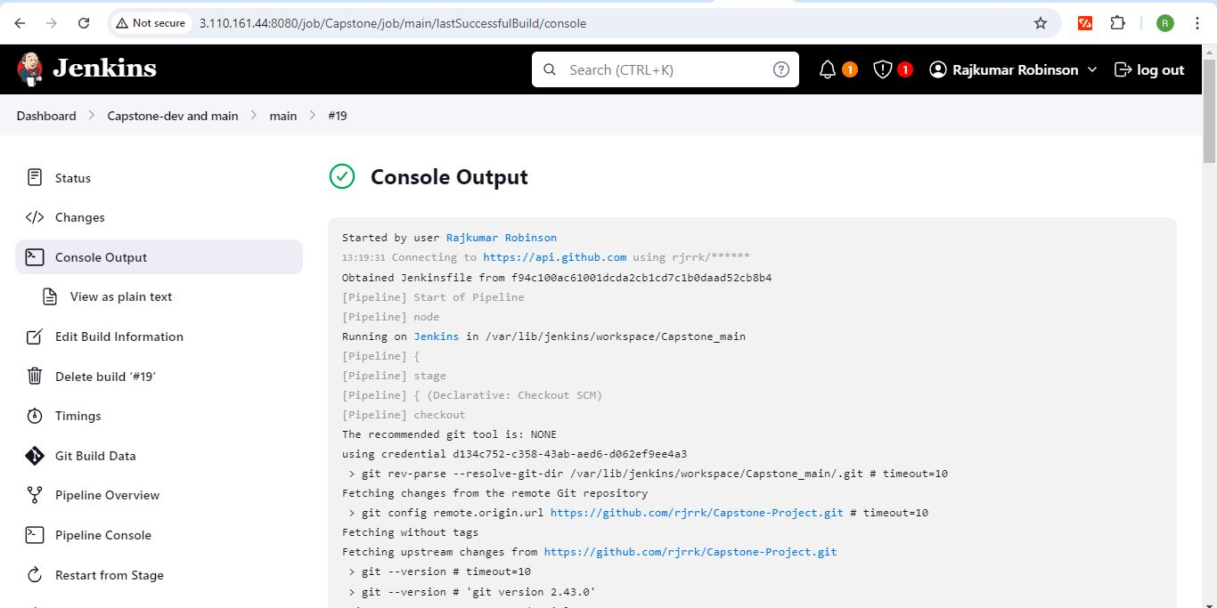

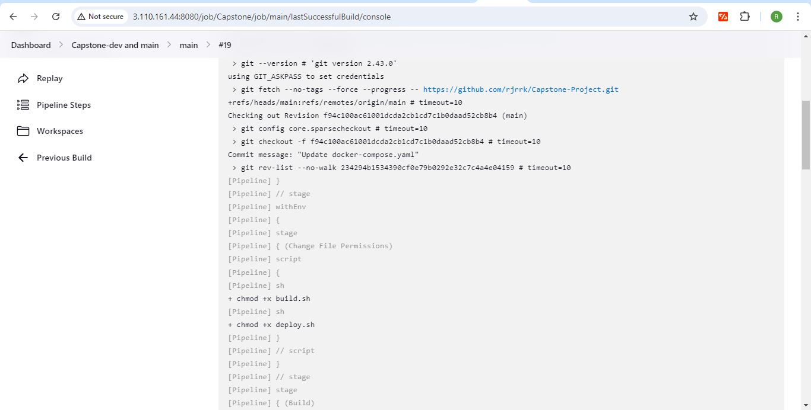

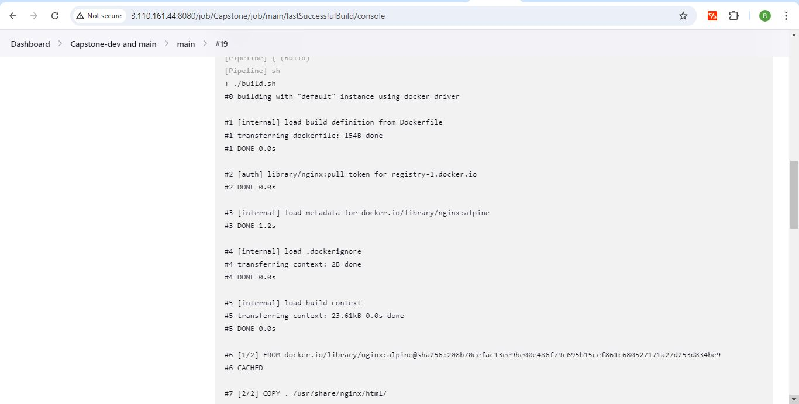

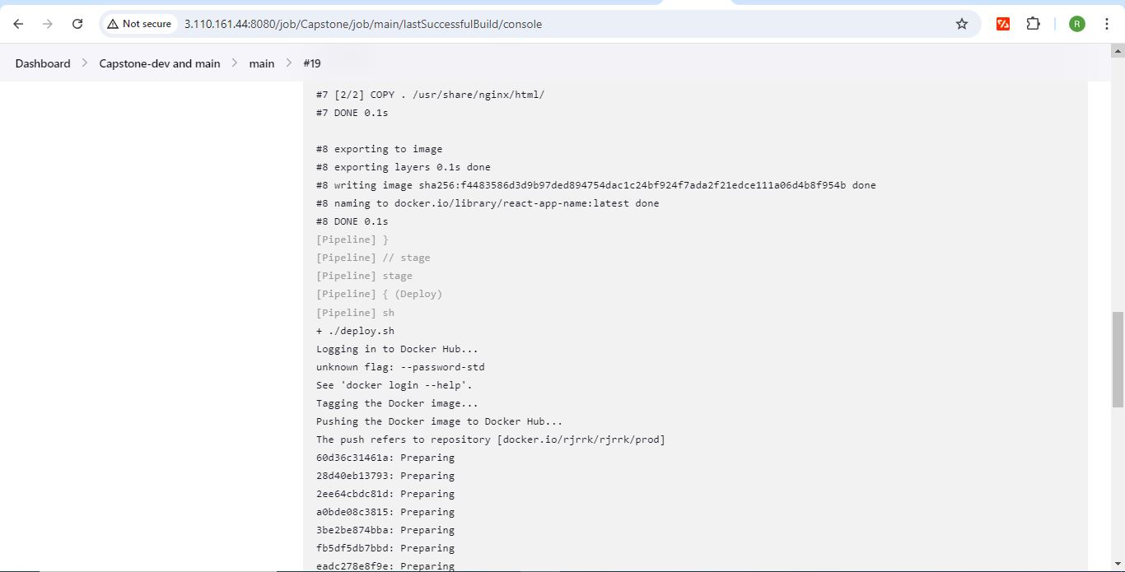

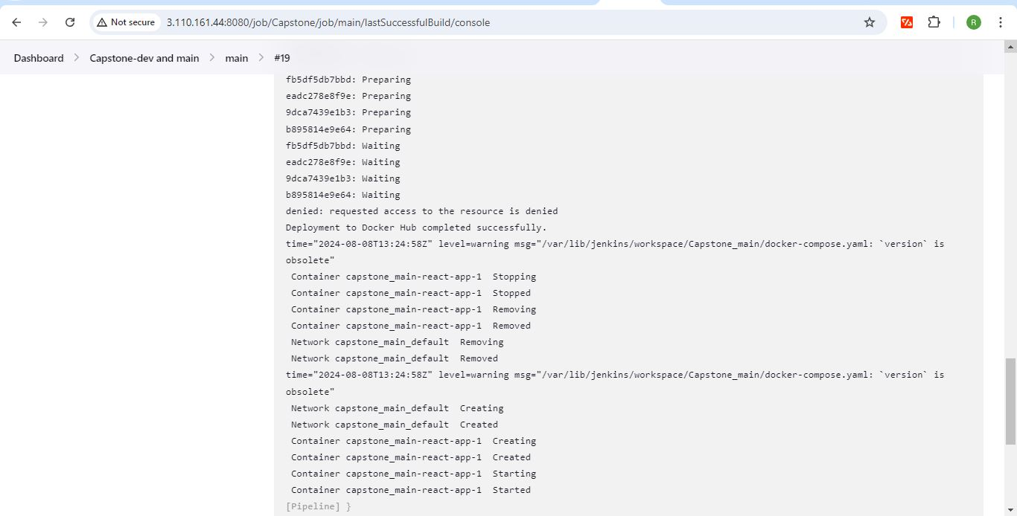

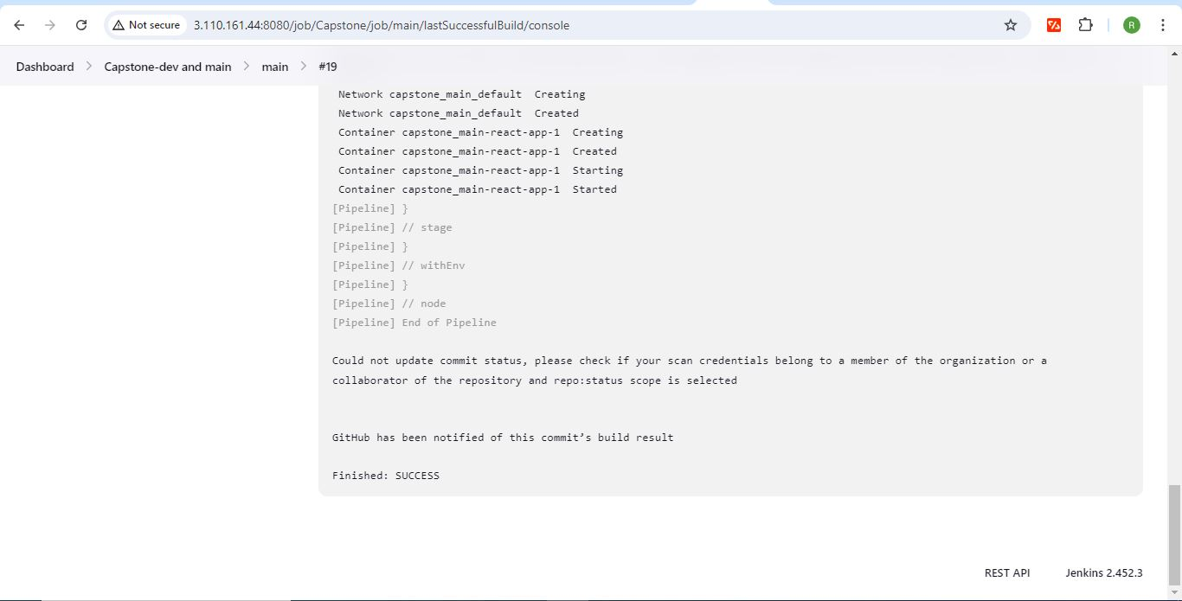

**AWS:**

Launch a t2.micro instance and deploy the application

* Log in to the server should be made only by my IP address.
* Whoever has the IP address can access the application.

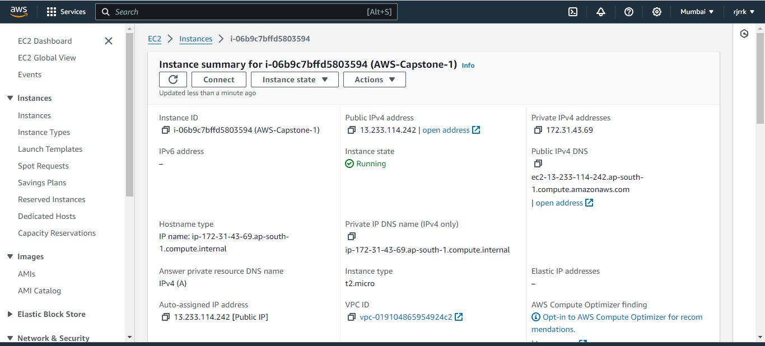

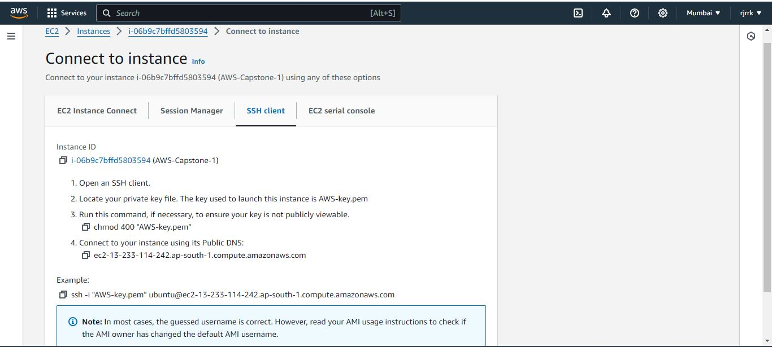

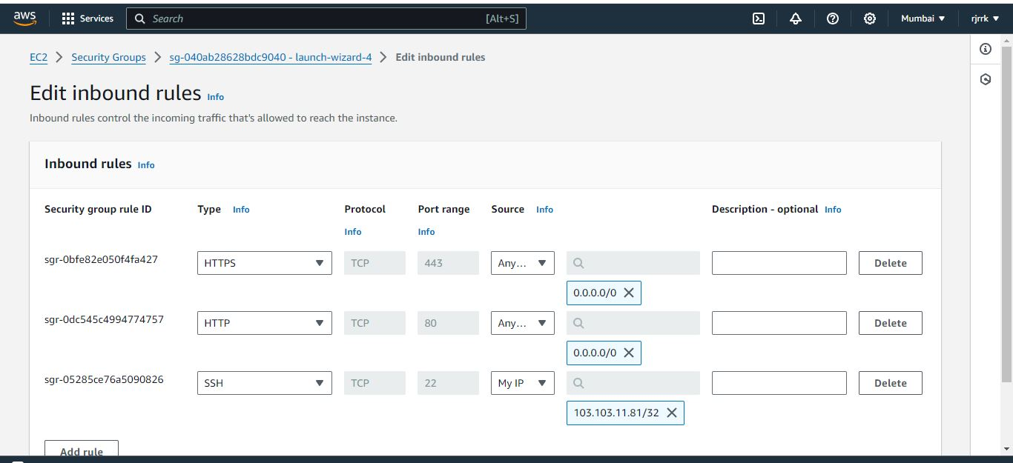

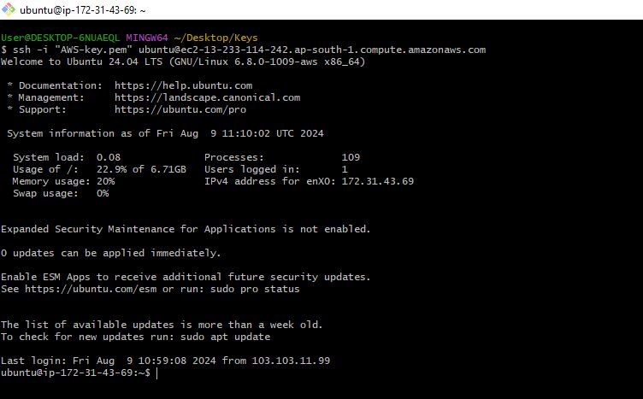

s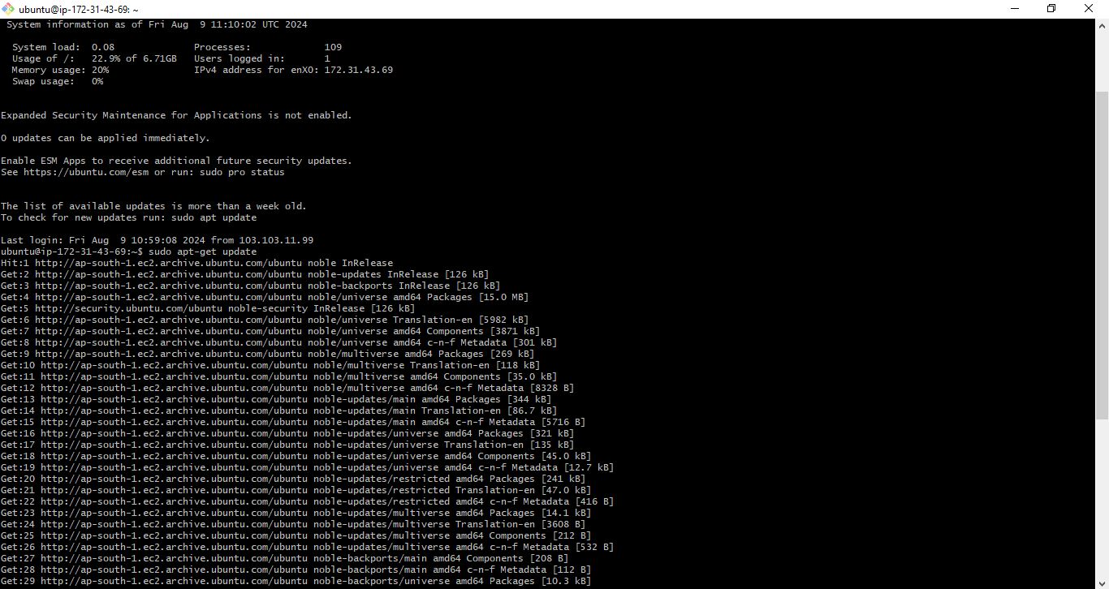

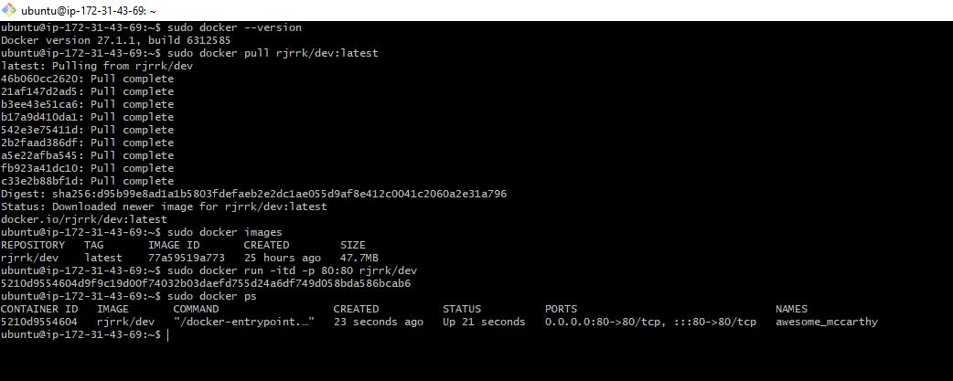

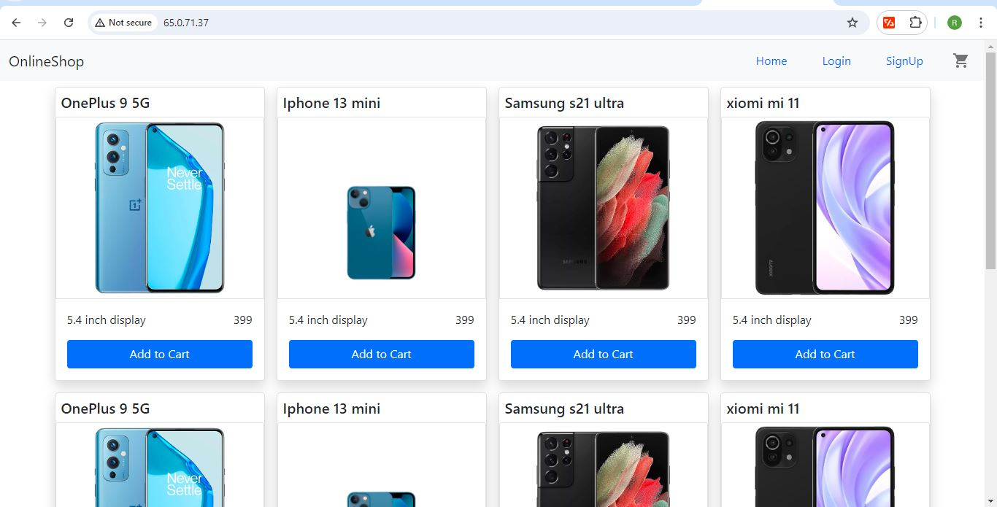

**Monitoring:**

* Set up a monitoring system to check the health status of the server

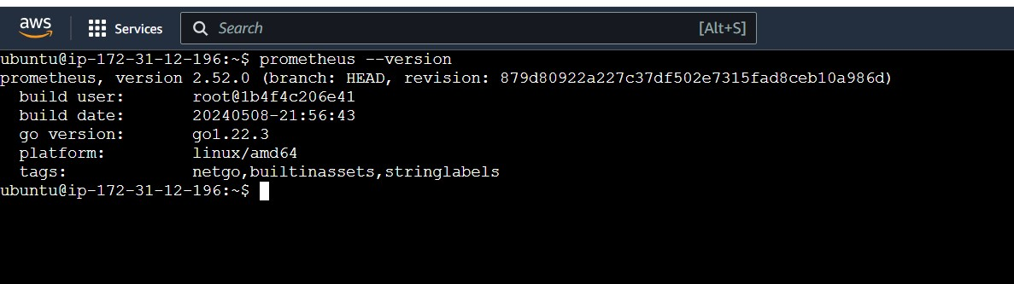

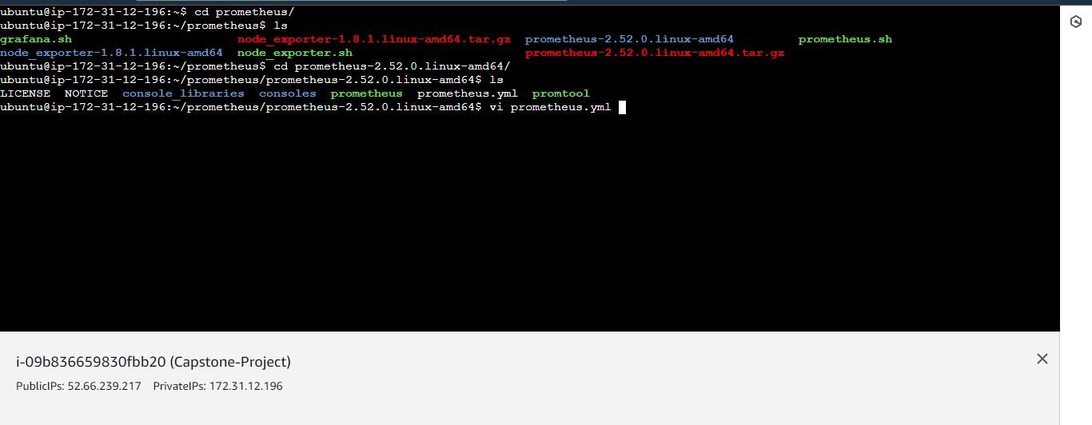

Prometheus

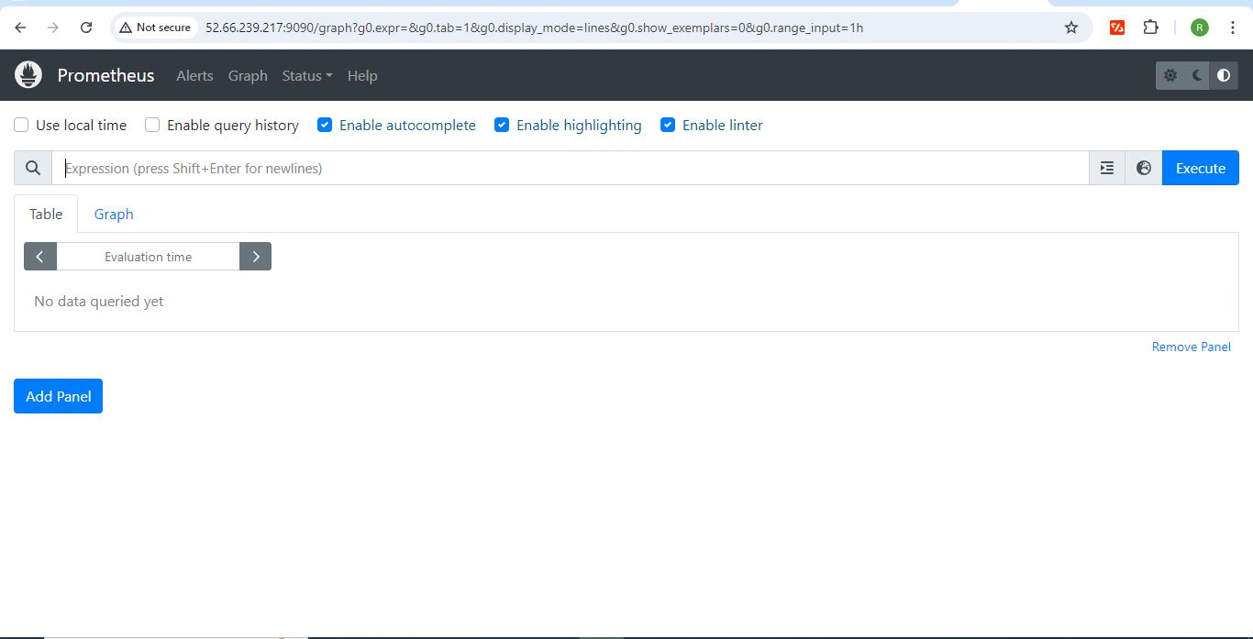

Grafana:

